Attachment C – Current LEP maps

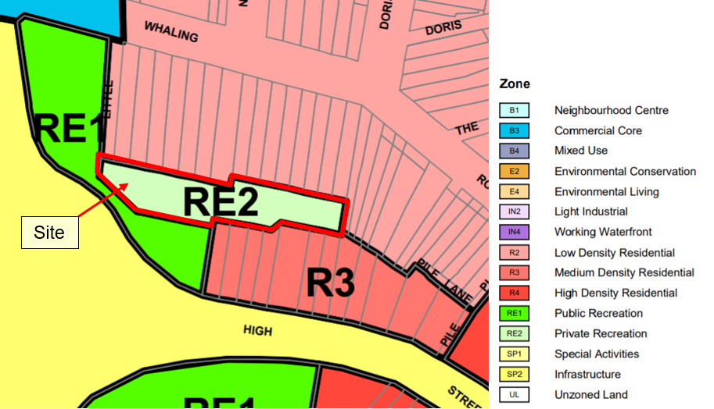Figure 1: Land zoning map LZN_002A (source: NSW Planning Portal)
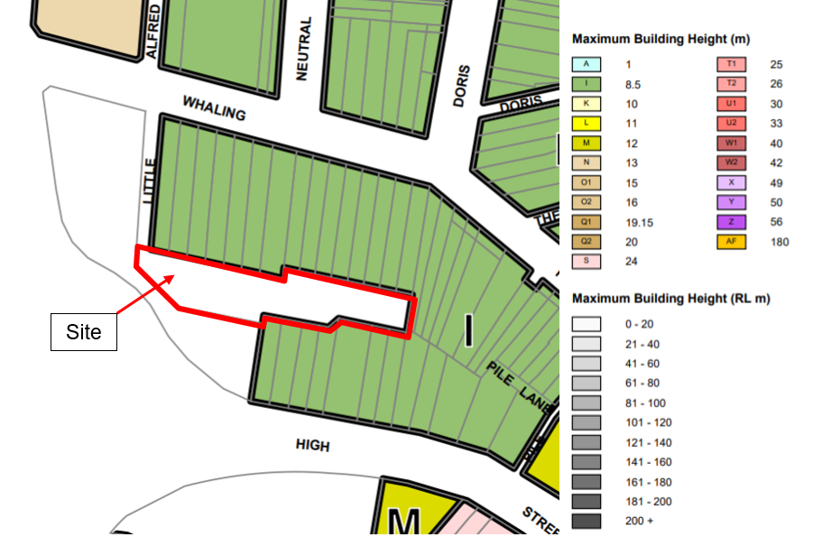Figure 2: Maximum height of buildings map HOB_002A (source: NSW Planning Portal)
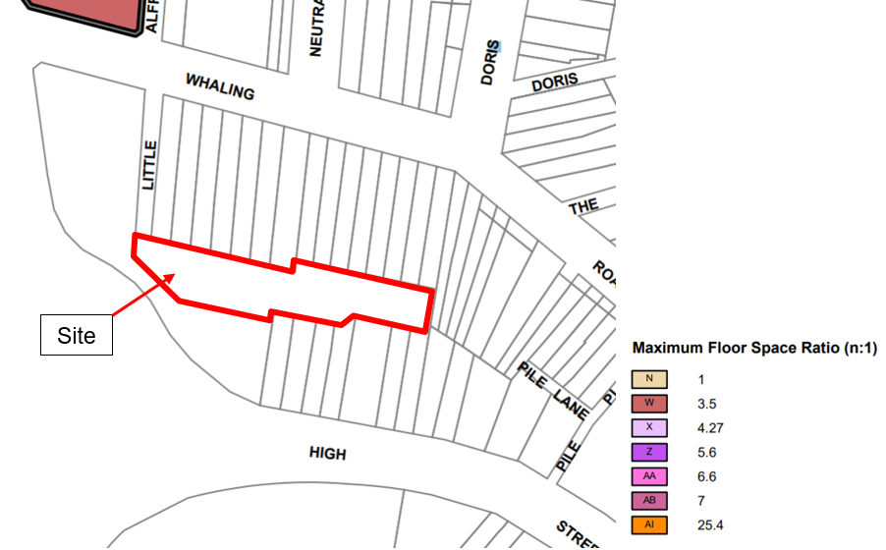Figure 3: Maximum FSR map FSR_002A (source: NSW Planning Portal)
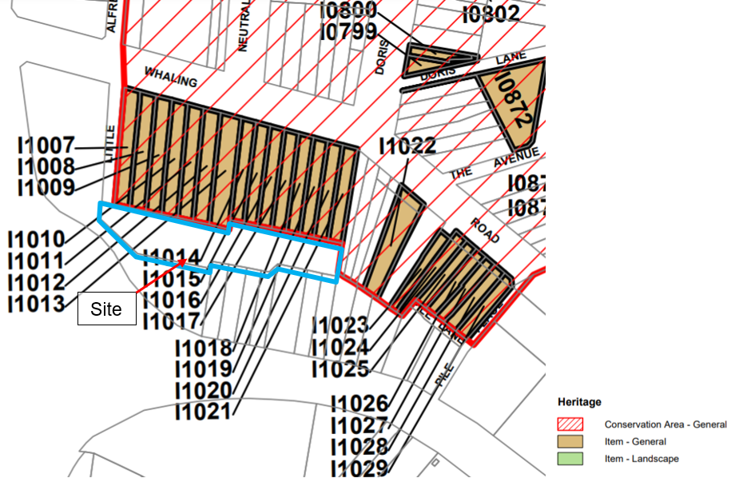
Figure 4: Heritage map HER_004 (source: NSW Planning Portal)

